**Valence Software – Updates – 11.05.2021**

**General New Funtion**

* **Login with URL parameter** 
  + The present login option should still be possible

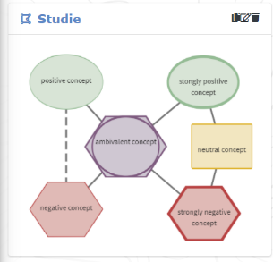**Corrections of the present software**

Pic 1

* **Complete translation (currently the English and German versions are mixed)**
  + We (Freiburg group) could insert the text translations in the respective file?
* Delete the following
  + Delete default thumbnail for CAMs (pic 1)
    - Thumbnail for drawn CAMs would be nice, but at the moment it is only workig sometimes?
  + Delete all sidebar sections except for the “contributors” and the “Home/Dashboard”-button (the little house)
  + Delete the mailadress input field for participants, when they Login
    - The Mailadress-password function is good, but so far it is not working?
  + Delete the “Settings” Button/Information after continuing without registration
  + Delete the picture option when registering as a researcher
* Registration
  + Login as Project Participant: If I check “Project participant” but don´t type a project name/password, I will be logged in as a normal user – it would be nice, if an error message appears, with an information that the person has to give a project name/password or should not log in as a project participant
  + How often is it possible at the moment to try to log in with the wrong password?
    - Would it be too complext that users are blocked if they log in wrong for e.g. 10 times and researchers could unblock participants of their project?
  + The order of input fields should be changed

|  |  |  |
| --- | --- | --- |
|  | **Participant Account** | **Researcher Account** |
| **So far** | * User Name * E-Mail * Language Preference * Project Participant * User Password / User Password Verification | * Fist Name * Last Name * User Name * Mail Adress * Password / Password Verification * Language Preference |
| **New** | * User Name * User Password / User Password Verification * Project Participant * Language Preference | * Fist Name / Last Name * Password / Password Verification * Mail Adress * Language Preference |

* Drawing CAMs
  + Creating a new CAM
    - **When participants want to create a new CAM, starting from a Dashboard, they can only draw CAMs in a new project – this should be changed, so that they can also draw CAMs without assigning to a project**
      * Also at the moment, when participants try to “join project” without checking the project box, they receive an error message but at the same time a new CAM will be created – there should be no error message
      * Also sometimes one click on “project participant” is enough and the project name/password appears, but often you have to double click – why is that and can it be solved? This is also the case when registering)
    - At the moment, when people create a new CAM, starting from the Dashboard, they will not be forwarded directly to the CAM software (they will end on the dashboard and have to click the new CAM again) – if this can be changed, it would be nice
  + 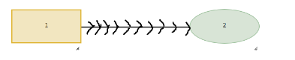**Creating links**

Pic 2

* + - Arrow heads are often not visible (because they are behind the concepts?)
      * Is that something you can solve?
        + If not: would it be an option to change the arrow style (pic 2)
    - I think at the moment the arrow direction is deafult (from the older concept to the newer)
      * Can this be changed, so that the arrow goes from the concept that people click first, to the concept they click second?
    - At the moment Multi-Links (5+) between two concepts are possible
      * Could you change to the following (do you assume that this is error-prone?)
        + Not more than one undirected link
        + Not more than two directed links
  + Creating Nodes
    - At the moment researchers and participants can change the nodes’ size. Can you change it so that nodes’ sizes can only be changed in researcher account CAMs?
    - What is the present limit of words/characters a node can bear?
      * Can you add an error message if people type too many characters?
* Zoom Function
  + CAM zooms out to the upper left side
    - 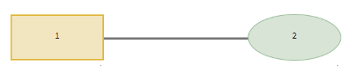Is it possible that the CAM stays centered?
    - Or is it possible to shift the whole CAM? (mark all and drag it?)
* **Picture Export**

Pic 3

* + 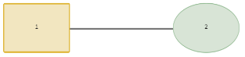Pictures are often cut and therefore not complete
    - Is it possible to change this?
  + The layout of the nodes in the pics is different than in the software (the pics’ layout corresponds with the old CAM layout where neutral nodes seem to be square-shaped (now it´s somehow stretched?) pic 3
* CAM import
  + 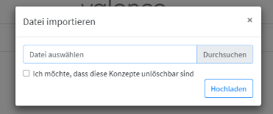It is possible to import CAMs, but at the moment it is not clear, that the CAM-file was “found/selected” – pic 4

Pic 4

* + - Make file path appear in the input field?
    - + error message if no file could be found
  + Please add a note, which file format is needed
  + At the moment, you can choose to make concepts not deletable – can you add a second choice that the whole CAM is not deletable?
* Researcher Account
  + Create a project with initial concept list
    - Add a note, which file format has to be uploaded
    - **Option, that concepts are not deletable does not work at the moment!**
  + At the moment researchers can delete participants’ accounts but it is not clear, that they delete the whole account
    - 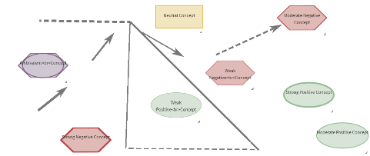Please make two options (“Delete single CAM” and “Delete participant account” – but deletion of participant account should only be allowed if the participant has not signed into other projects)

Pic 5

* + **At the moment, when participants sign a project with an initial concept list, and they change this CAM, the links don´t move (see pic 5)**
  + Please add a note, that researchers agree with the terms of use when they registrate
* **ID-Data-Mysteries**
  + Nodes and links have IDs; starting and ending block refer to the nodes’ IDs
    - Now sometimes it seems to be the case, that IDs of the nodes change, e.g. when you upload an exported CAM. The new, uploaded CAM with the same nodes will have differend IDs for those nodes, but the links’ starting and ending blocks refer to the old CAM
      * Does that cause further Problems? E.g.:
    - This does cause problems with the Initial Concept list
      * If a participant creates a CAM in a project, where an initial concept list was uploaded, the CAM od the participant will get new IDs for the nodes and links, but the starting and ending block will refer to the initial concept list CAM
        + **Also this causes some fancy dynamics, such as deletion of initial CAMs, if they are imported and changed somewhere else!**
* Can we have something like a “master-account” – which allows us to delete accounts?
* Would it be easy to give researchers and participants the option to delete their account?
* Can you add a date to the time-stamp?
* Can we make version codes for the software?
* **Generally we would test with Chrome and Safari** – they seem to work similar
  + Only addition problem with Safari at the moment: exported pictures do not show links

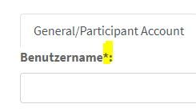**Less important/Optional/Usability**

Pic 6

**General**

Pic 7

* 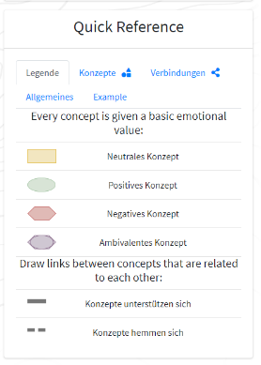Can you add an explanation for the asterix? (Pic 6)
* Can you add a note on conditions for entries (No umlauts and special characters)

**New Registration/Login**

* Add “Continue without registering” also on the “New Registration” site

**Logged in**

* Can you add arrows to the legend (pic 7)?
* When drawing a CAM: Can you indicate, in which project the user created the CAM at the moment? (Info next to the user name in the upper right corner?)